SA463 • Operations Research in Action Fall 2024 • Uhan

**Project 1 – Data – Feedback**

Let’s discuss and revise some common issues.

* When describing the columns/variables of tabular data, describe what the values *represent*. Don’t just state the column headings.

The second table provides monthly data on the number of tourists who visited Turkey from 1987 to 1993, and has the columns Year, Month, Czechoslovakia, Germany, the United Kingdom, the United States, France, and Others.

* Tables and figures. Number tables and figures separately. Revise variable names so they are reader-friendly and proper English. Include descriptive captions. Don’t use screenshots of tables – take the time and effort to make them look nice by using tables in Word/Docs. For larger tables, consider using a slightly smaller font.

|  |  |  |  |  |
| --- | --- | --- | --- | --- |
|  | Mean | Std. Deviation | Minimum | Maximum |
| BeerConsumption | 30702442 | 13920617.83 | 12140503 | 69983870 |
| AverageBeerPrice | 1298.03849 | 88.32131016 | 1110.010066 | 1480.456245 |
| AverageRakiPrice | 7592.54452 | 852.9888071 | 5593.1 | 9715.74 |
| AverageCannedSoftDrinkPrice | 1803.5631 | 198.2951954 | 1408.5 | 2295.12 |

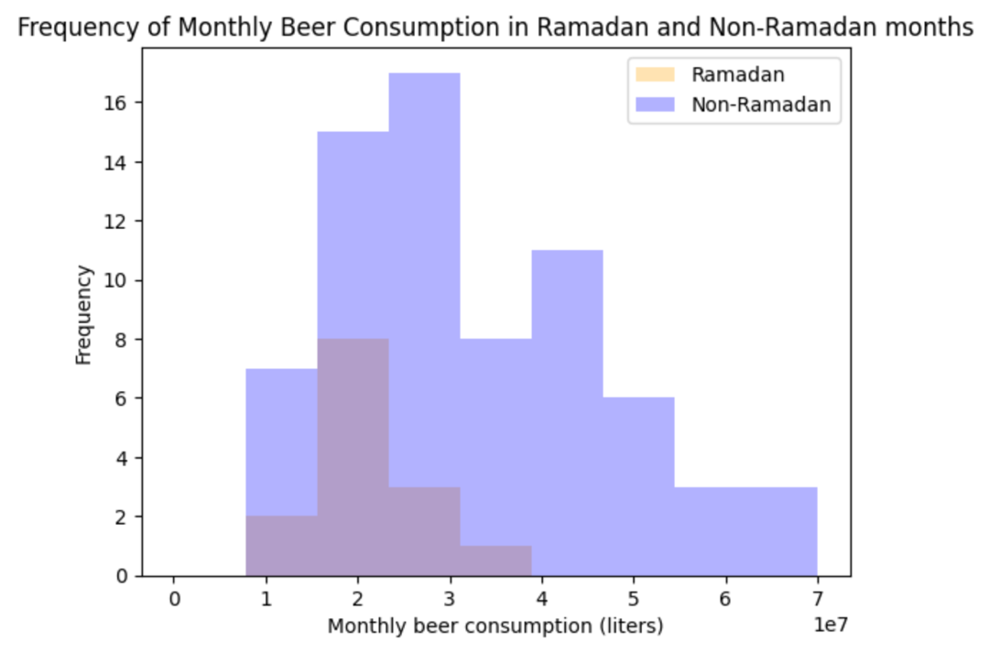

* Don’t forget to include summary statistics for key variables!
  + df.describe() generates summary statistics for all numeric variables in the DataFrame df (like in the table above).
  + Pro tip: df.describe().to_clipboard() puts the contents of df.describe() into the clipboard. Then you can paste those contents into an Excel spreadsheet, and then copy and paste those contents into a Word document.
* When describing how you merged tables together, remember to specify the variables you used to match the rows. Don’t mention specific functions or methods.
* It’s conventional to use the plural first person (“we”, “our”) when writing technical project reports. Think about your writing as taking your reader along your process.

I wrangled the data by merging each table with demand_price_df.merge() to create a single table that has every variable.